Generator

Definition
# Source: AI Source: Provided by: [Data Path: Persons Table -> ID Column: 1, Name_En Column: Motasem Essam] -> From: [ChatGPT] on [7/25/2026]
A generator (also called a generating line or generatrix) is a point, line, curve, or other geometric element that moves according to a specified rule to generate a geometric surface or solid.
In solid geometry, the term most commonly refers to a moving straight line or curve that generates a surface. The path or boundary followed by the moving element determines the resulting geometric shape.
For example:
- A moving straight line can generate a cylindrical surface.
- A moving straight line passing through a fixed point can generate a conical surface.
- A rotating line or curve can generate a surface of revolution.
- A rotating plane region can generate a solid of revolution.
The exact meaning depends on the geometric construction being described.

Geometric Representation
# Source: AI Source: Provided by: [Data Path: Persons Table -> ID Column: 1, Name_En Column: Motasem Essam] -> From: [ChatGPT] on [7/25/2026]
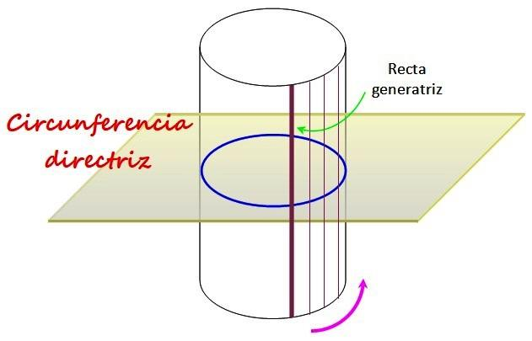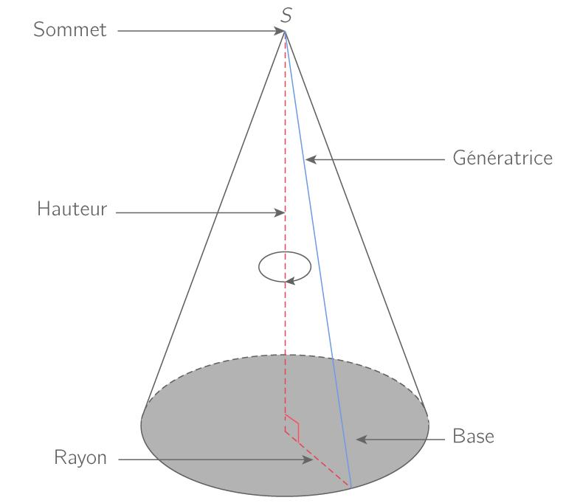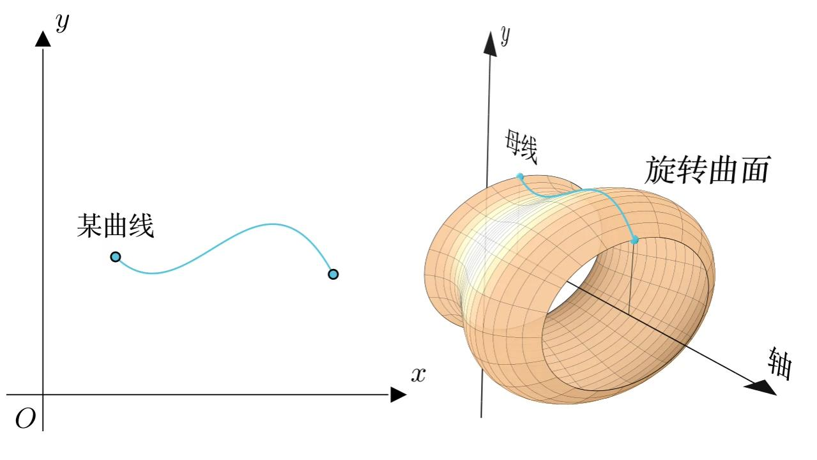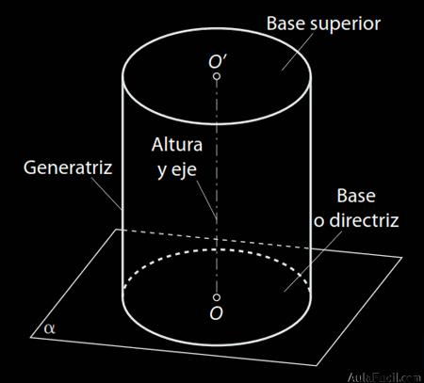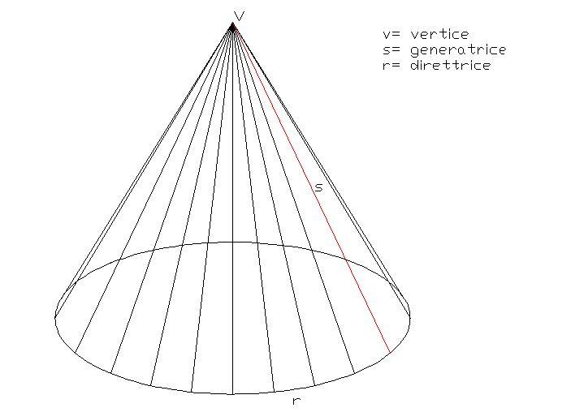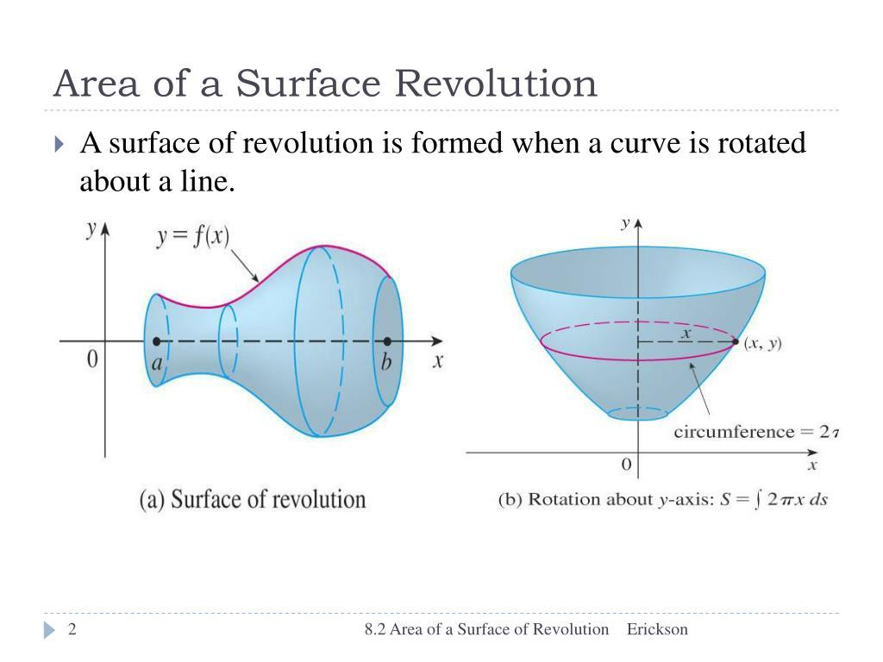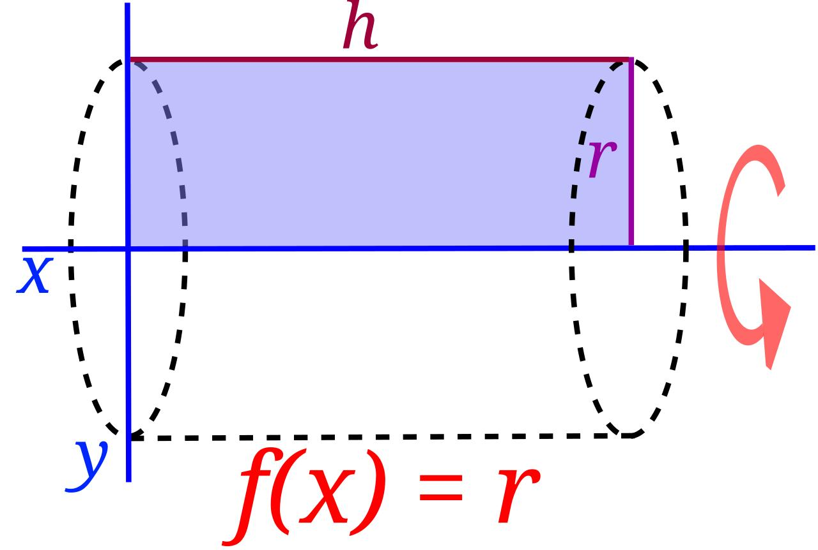

Geometric Structure
# Source: AI Source: Provided by: [Data Path: Persons Table -> ID Column: 1, Name_En Column: Motasem Essam] -> From: [ChatGPT] on [7/25/2026]
A generator is understood through its relationship with other elements of the geometric construction.
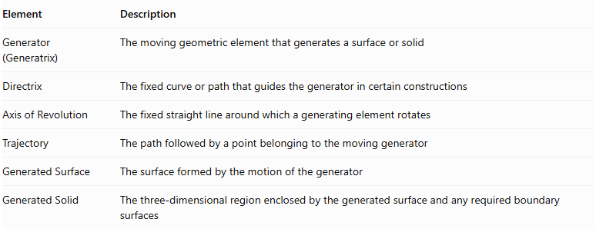
Element | Description
Generator (Generatrix) | The moving geometric element that generates a surface or solid
Directrix | The fixed curve or path that guides the generator in certain constructions
Axis of Revolution | The fixed straight line around which a generating element rotates
Trajectory | The path followed by a point belonging to the moving generator
Generated Surface | The surface formed by the motion of the generator
Generated Solid | The three-dimensional region enclosed by the generated surface and any required boundary surfaces
Important distinction: A generator is not always a line. In a surface of revolution, the generating element is commonly a curve; in the construction of a solid of revolution, the generating element may be a plane region.

Types of Generators in Solid Geometry

Straight-Line Generator
# Source: AI Source: Provided by: [Data Path: Persons Table -> ID Column: 1, Name_En Column: Motasem Essam] -> From: [ChatGPT] on [7/25/2026]
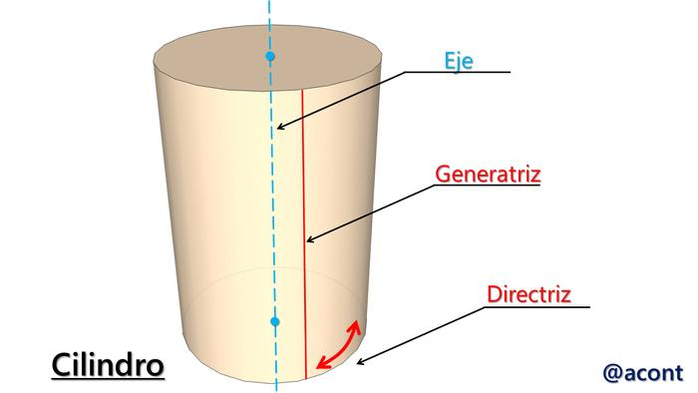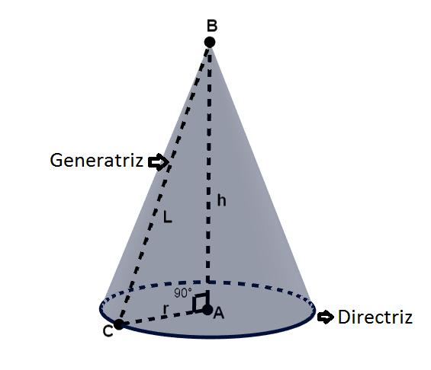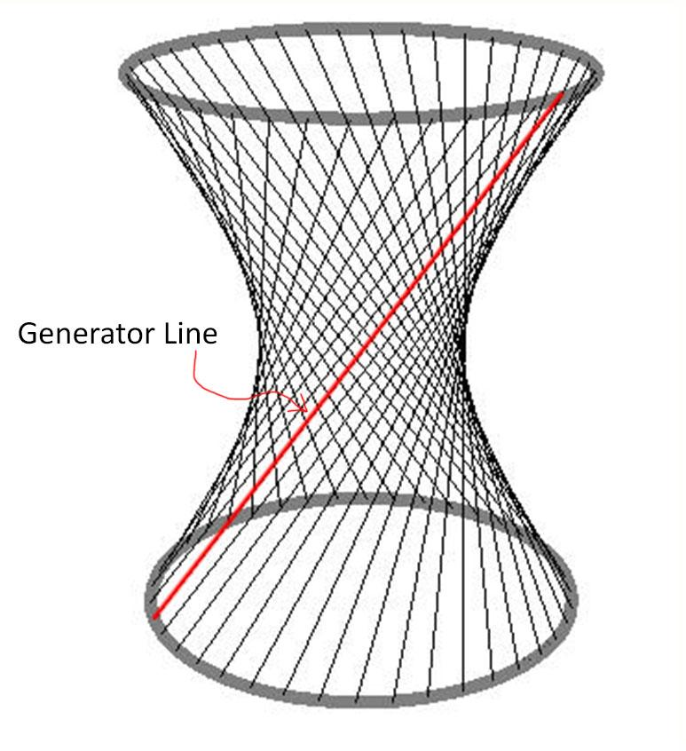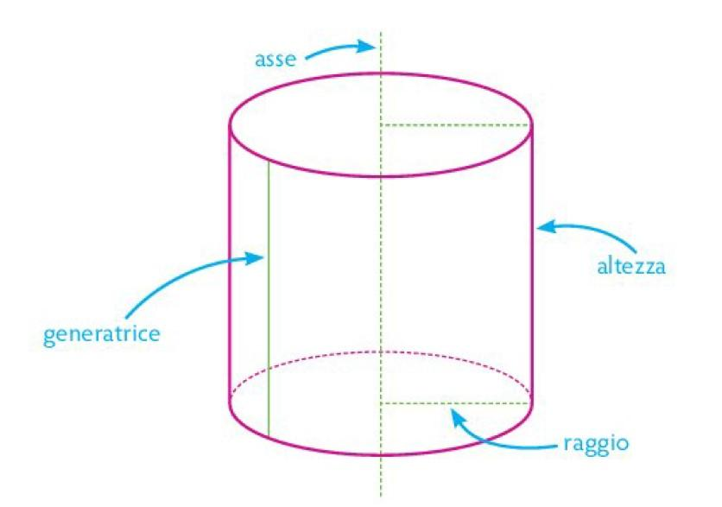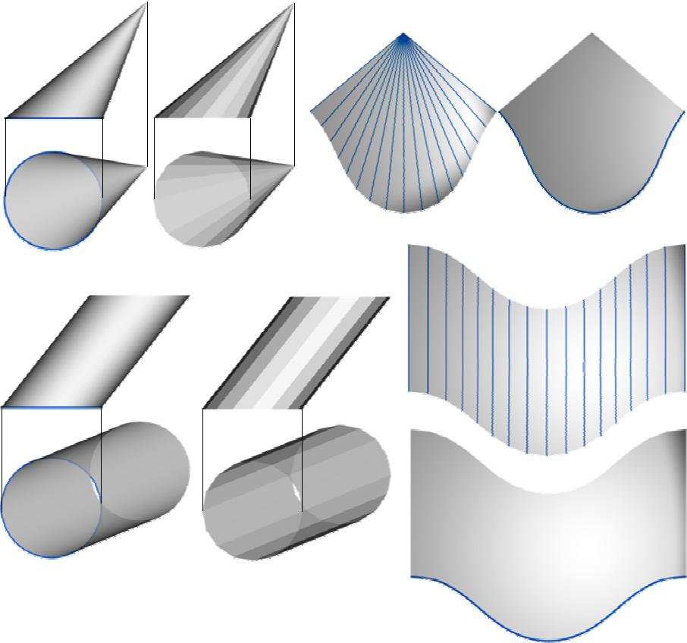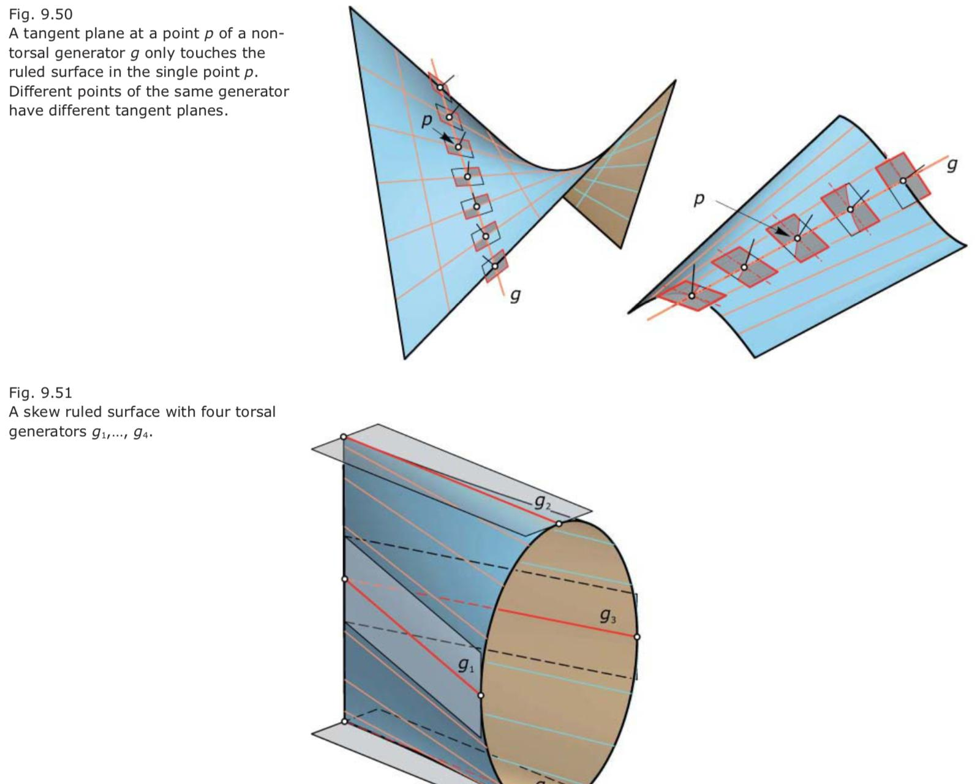
A straight-line generator is a moving straight line that generates a surface through its motion.
Examples:
- Cylindrical Generator: A straight line moves parallel to itself while following a closed directrix, generating a cylindrical surface.
- Conical Generator: A straight line passes through a fixed vertex while its other point moves along a directrix, generating a conical surface.
- Ruled-Surface Generator: A straight line moves through space according to a specified rule to generate a ruled surface.
For a cylinder, the moving line is parallel to the cylinder's axis. For a cone, the generator lines pass through the cone's vertex.

Curved-Line Generator
# Source: AI Source: Provided by: [Data Path: Persons Table -> ID Column: 1, Name_En Column: Motasem Essam] -> From: [ChatGPT] on [7/25/2026]
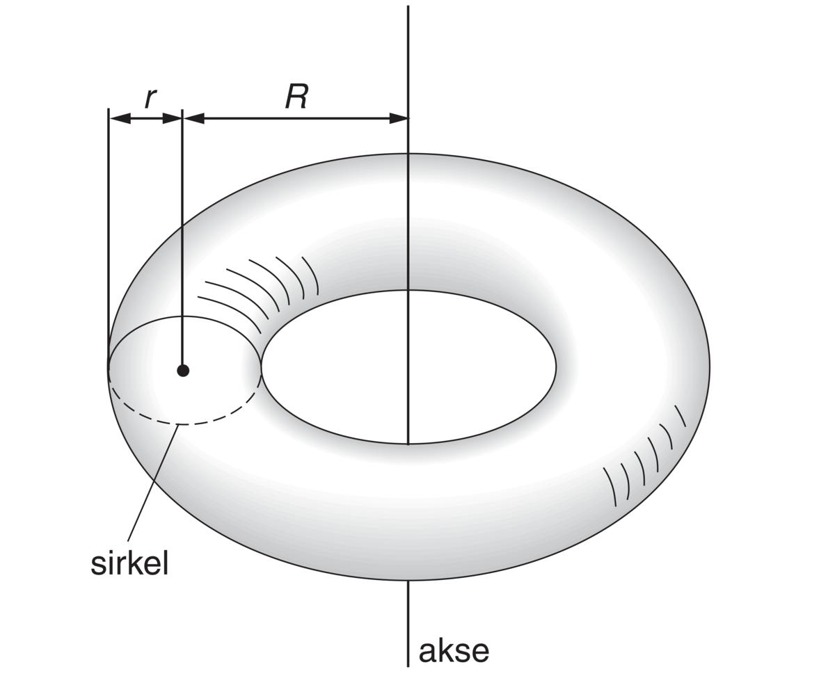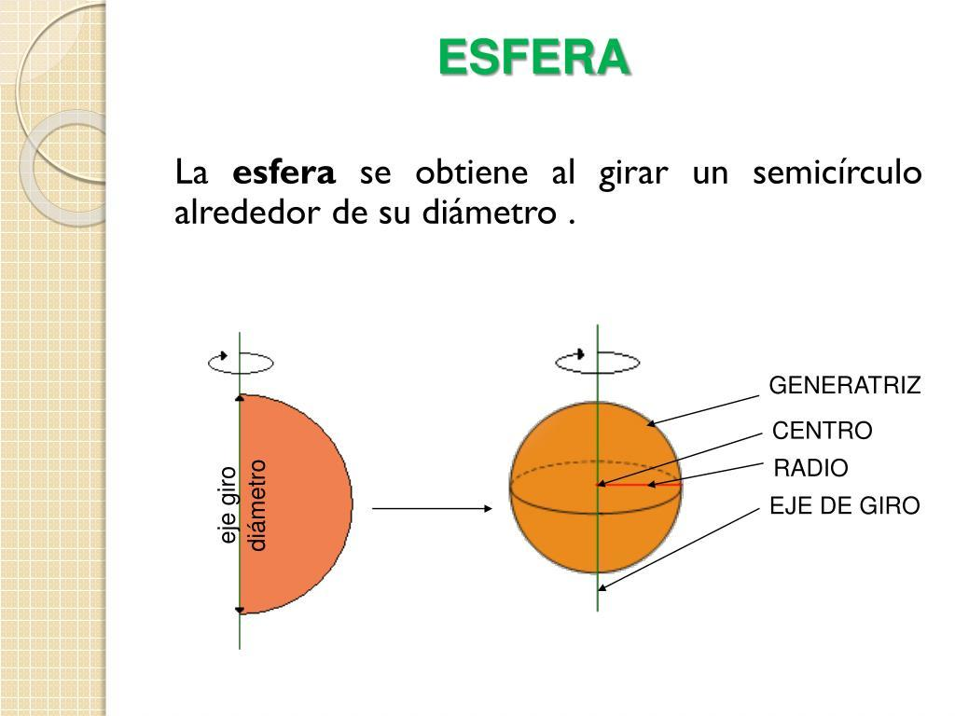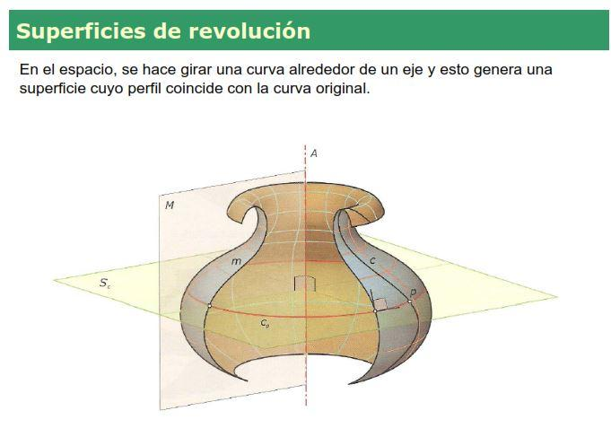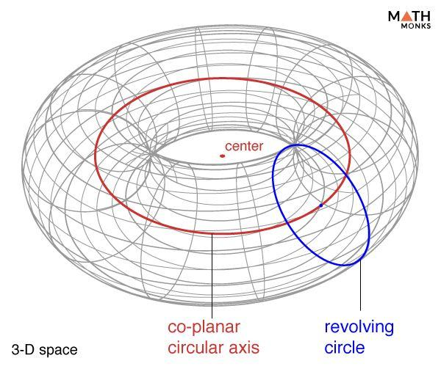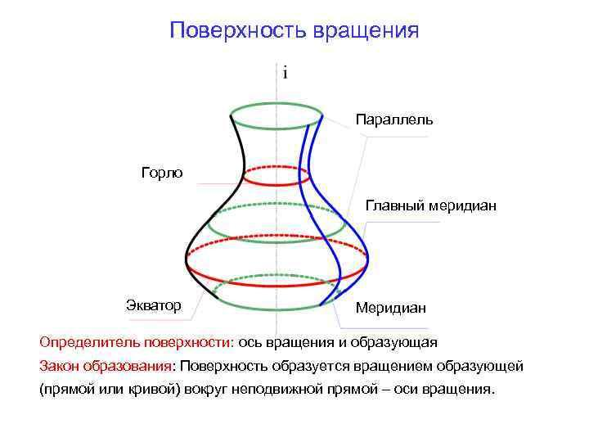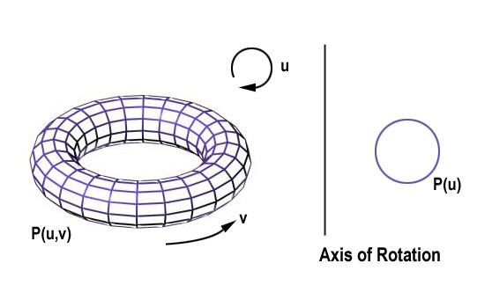
A curved-line generator is a curve that moves or rotates to generate a surface.
Examples:
- Spherical Generator: A semicircular arc rotates around its diameter to generate a spherical surface.
- Torus Generator: A circle rotates around an external coplanar axis that does not intersect its interior, generating a toroidal surface.
- General Surface-of-Revolution Generator: A plane curve rotates around a fixed axis to produce a surface of revolution.

Plane-Region Generator
# Source: AI Source: Provided by: [Data Path: Persons Table -> ID Column: 1, Name_En Column: Motasem Essam] -> From: [ChatGPT] on [7/25/2026]
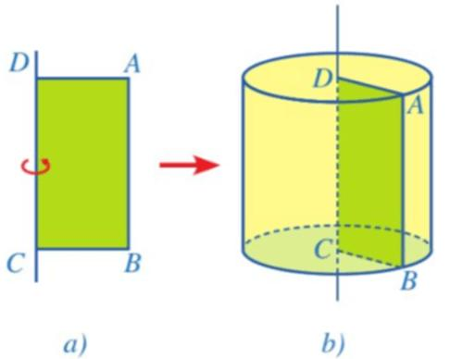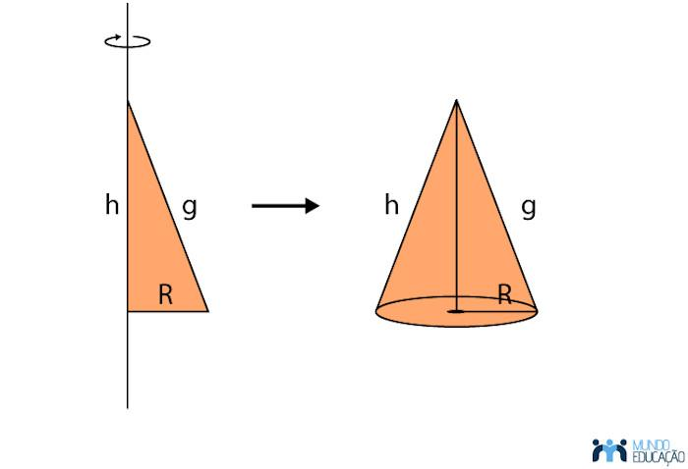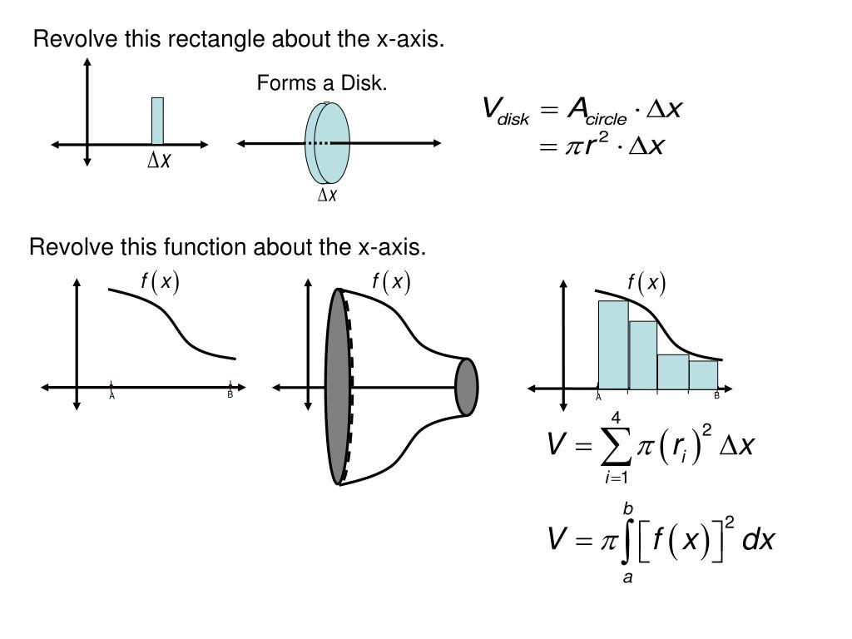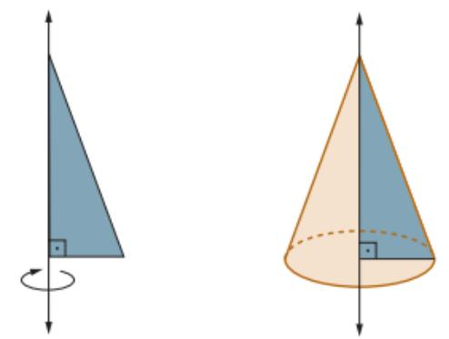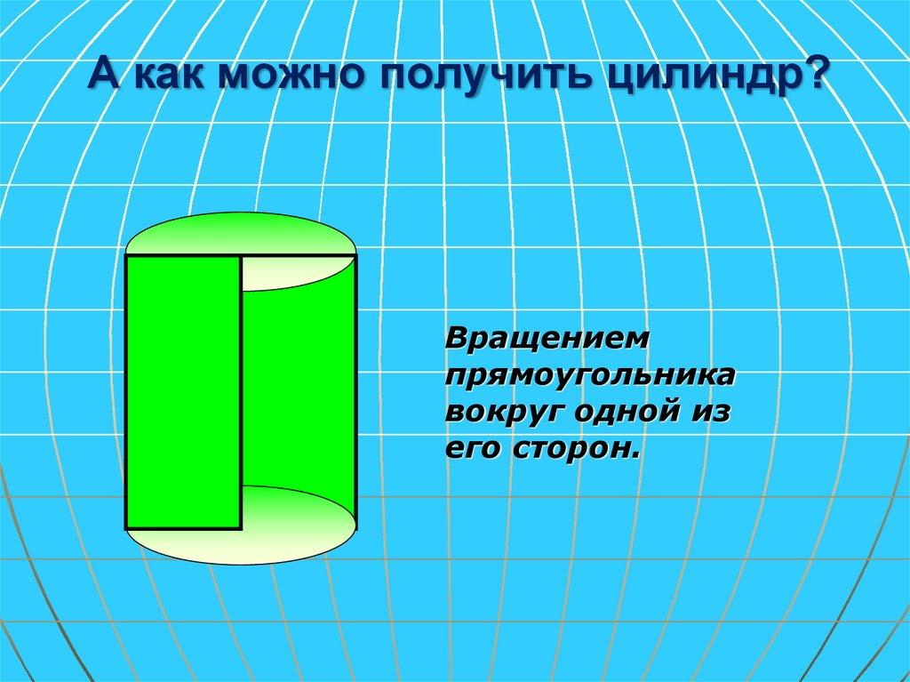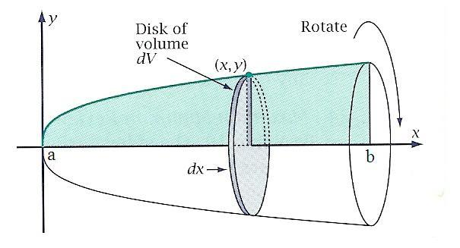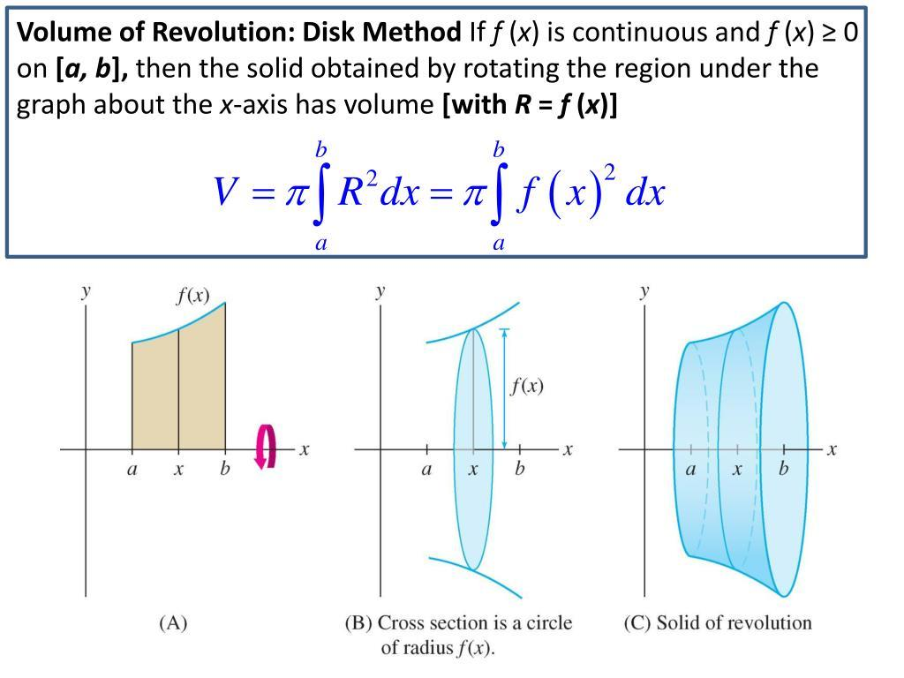
A plane-region generator is a two-dimensional region that moves or rotates to generate a three-dimensional solid.
Examples:
- Circular Disk: Rotating a rectangular region around one of its sides generates a cylinder.
- Right Triangle: Rotating a right-triangular region around one of its perpendicular sides generates a cone.
- Semicircular Region: Rotating a semicircular region around its diameter generates a sphere.
- Circular Region: Rotating a circular region around an external coplanar axis generates a toroidal solid.
These are examples of solids of revolution.

Generator in Common Geometric Solids
# Source: AI Source: Provided by: [Data Path: Persons Table -> ID Column: 1, Name_En Column: Motasem Essam] -> From: [ChatGPT] on [7/25/2026]
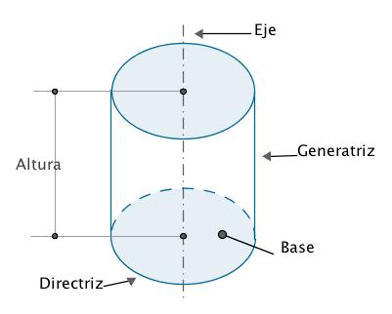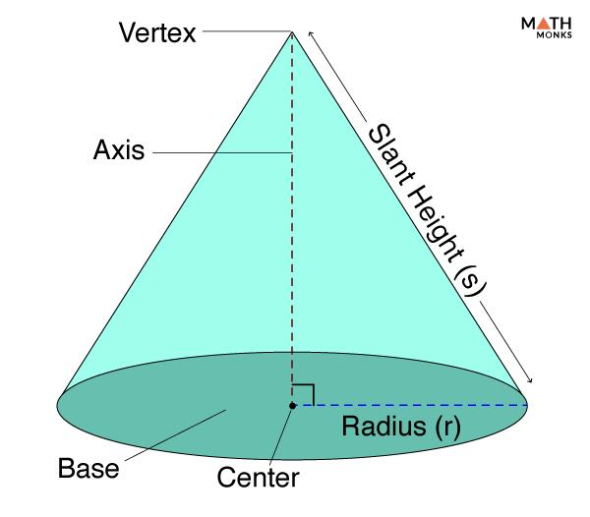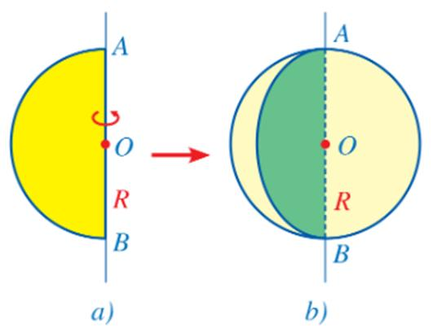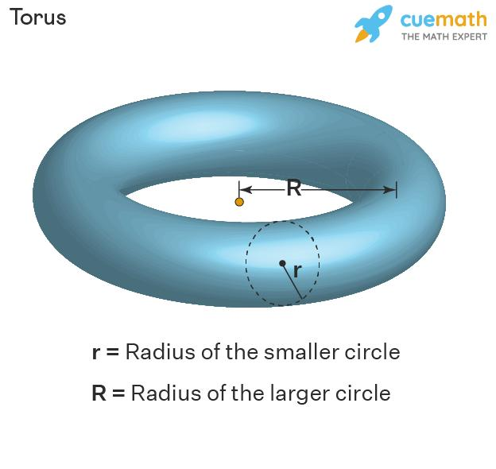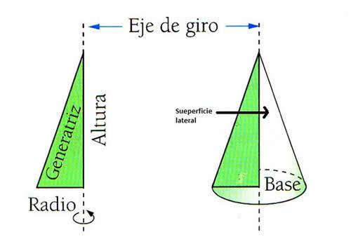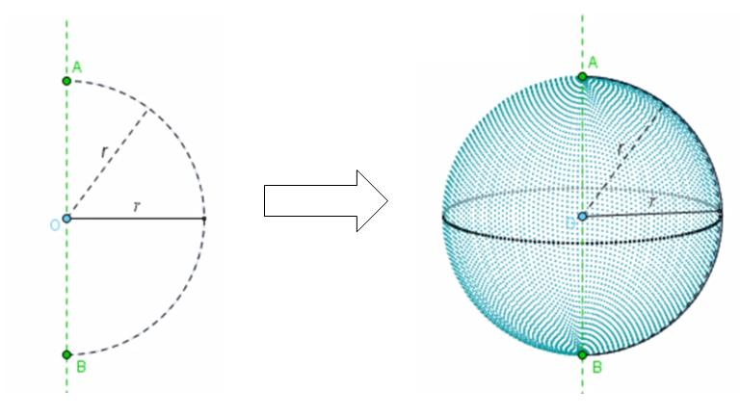
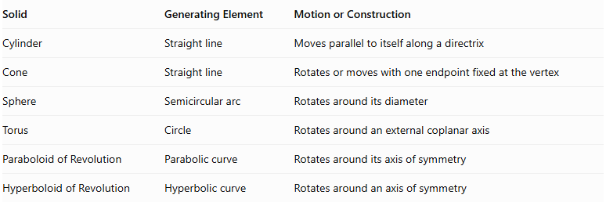
Solid | Generating Element | Motion or Construction
Cylinder | Straight line | Moves parallel to itself along a directrix
Cone | Straight line | Rotates or moves with one endpoint fixed at the vertex
Sphere | Semicircular arc | Rotates around its diameter
Torus | Circle | Rotates around an external coplanar axis
Paraboloid of Revolution | Parabolic curve | Rotates around its axis of symmetry
Hyperboloid of Revolution | Hyperbolic curve | Rotates around an axis of symmetry

Mathematical Representation
# Source: AI Source: Provided by: [Data Path: Persons Table -> ID Column: 1, Name_En Column: Motasem Essam] -> From: [ChatGPT] on [7/25/2026]
The mathematical representation of a generator depends on the type of surface or solid being generated.

Generator of a Cylinder
# Source: AI Source: Provided by: [Data Path: Persons Table -> ID Column: 1, Name_En Column: Motasem Essam] -> From: [ChatGPT] on [7/25/2026]
A cylindrical surface can be generated by moving a straight line parallel to a fixed direction while it follows a directrix.
A general parametric representation is:
$$X(u,v)=c(u)+vd$$
Where:
- $c(u)$ represents the directrix.
- $d$ is the fixed direction of the generator.
- $v$ represents the position along the moving line.

Generator of a Cone
# Source: AI Source: Provided by: [Data Path: Persons Table -> ID Column: 1, Name_En Column: Motasem Essam] -> From: [ChatGPT] on [7/25/2026]
A conical surface can be generated by straight lines passing through a fixed vertex and points on a directrix.
$$X(u,v)=A+v(c(u)-A)$$
Where:
- $A$ represents the cone vertex.
- $c(u)$ represents the directrix.
- $v$ determines the position along each generator.

Generator of a Surface of Revolution
# Source: AI Source: Provided by: [Data Path: Persons Table -> ID Column: 1, Name_En Column: Motasem Essam] -> From: [ChatGPT] on [7/25/2026]
A curve can generate a surface by rotating around a fixed axis.
For a curve represented by:
$$(r(v),z(v))$$
rotating around the $z$-axis gives:
$$x=r(v)cosu$$
$$y=r(v)sinu$$
$$z=z(v)$$
Where:
$$0≤u≤2π$$
Here, $u$ is the rotation angle and $v$ identifies a position along the generating curve.

Generator vs. Directrix vs. Axis of Revolution
# Source: AI Source: Provided by: [Data Path: Persons Table -> ID Column: 1, Name_En Column: Motasem Essam] -> From: [ChatGPT] on [7/25/2026]
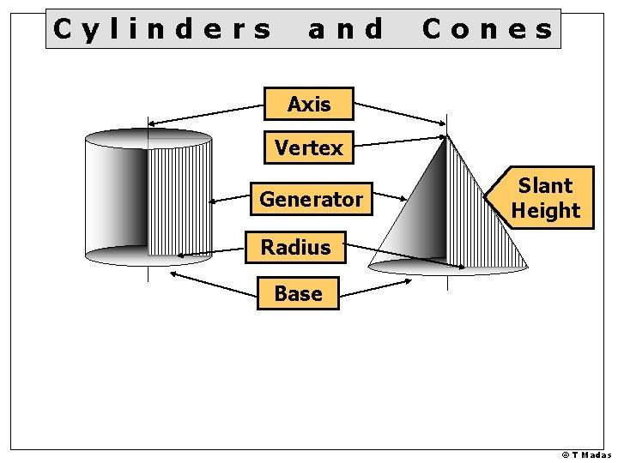
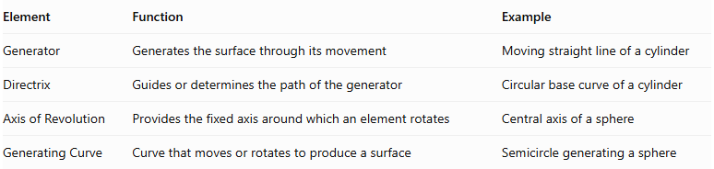
Element | Function | Example
Generator | Generates the surface through its movement | Moving straight line of a cylinder
Directrix | Guides or determines the path of the generator | Circular base curve of a cylinder
Axis of Revolution | Provides the fixed axis around which an element rotates | Central axis of a sphere
Generating Curve | Curve that moves or rotates to produce a surface | Semicircle generating a sphere
Note: Not every generator requires a directrix or an axis of revolution. These elements depend on the construction method.

Important Geometric Terms
# Source: AI Source: Provided by: [Data Path: Persons Table -> ID Column: 1, Name_En Column: Motasem Essam] -> From: [ChatGPT] on [7/25/2026]
- Generatrix: Another term for the generating element, particularly a line or curve that generates a surface.
- Generator Line: A straight-line generator.
- Generating Curve: A curve used to generate a surface.
- Generating Region: A two-dimensional region used to generate a solid.
- Element of a Surface: A particular position of a generator on the generated surface.
- Ruled Surface: A surface that can be generated by moving a straight line through space.

Main Classification
# Source: AI Source: Provided by: [Data Path: Persons Table -> ID Column: 1, Name_En Column: Motasem Essam] -> From: [ChatGPT] on [7/25/2026]
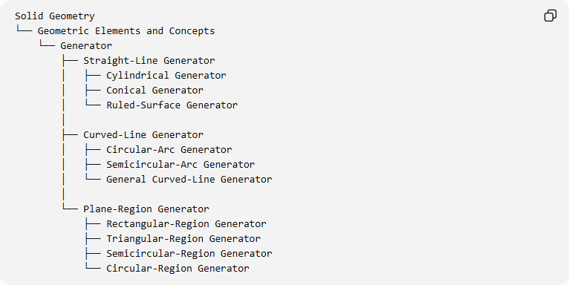
Solid Geometry
└── Geometric Elements and Concepts
└── Generator
├── Straight-Line Generator
│ ├── Cylindrical Generator
│ ├── Conical Generator
│ └── Ruled-Surface Generator
│
├── Curved-Line Generator
│ ├── Circular-Arc Generator
│ ├── Semicircular-Arc Generator
│ └── General Curved-Line Generator
│
└── Plane-Region Generator
├── Rectangular-Region Generator
├── Triangular-Region Generator
├── Semicircular-Region Generator
└── Circular-Region Generator

Key Points
# Source: AI Source: Provided by: [Data Path: Persons Table -> ID Column: 1, Name_En Column: Motasem Essam] -> From: [ChatGPT] on [7/25/2026]
- A generator is a geometric element whose motion produces a surface or solid.
- It can be a straight line, a curved line, or a plane region.
- A cylindrical surface can be generated by a moving straight line.
- A conical surface can be generated by straight lines passing through a fixed vertex.
- A sphere can be generated by rotating a semicircular arc around its diameter.
- A torus can be generated by rotating a circle around an external axis.
- A generator is different from a directrix and an axis of revolution.

Conclusion
# Source: AI Source: Provided by: [Data Path: Persons Table -> ID Column: 1, Name_En Column: Motasem Essam] -> From: [ChatGPT] on [7/25/2026]
The Generator (Generatrix) is a fundamental concept in solid geometry used to describe how geometric surfaces and solids are formed through motion. It provides the geometric basis for constructing cylinders, cones, spheres, tori, and other generated surfaces and solids.
References:
- Solid Geometry – Project Gutenberg
- Wolfram MathWorld – Surface of Revolution
- Ruled Surfaces and Generators

